AI-Based Football Match Outcome Prediction and League Table Simulation using XGBoost and Monte Carlo Methods

1. Problem and Motivation
Predicting football match outcomes is inherently challenging due to the low-scoring nature of the sport and the high degree of randomness involved. Unlike deterministic systems, football outcomes are influenced by multiple uncertain factors such as team form, match context, and stochastic events. In particular, draw outcomes are difficult to predict due to their relatively low frequency and ambiguous statistical patterns.
Traditional approaches relying solely on historical win/loss records often fail to capture underlying performance dynamics. In contrast, modern metrics such as Expected Goals (xG) provide a more informative representation of team performance by quantifying chance quality rather than final outcomes.
Beyond predicting individual matches, there is increasing interest in understanding season-level uncertainty. Rather than producing deterministic predictions, probabilistic approaches allow for simulation of entire seasons, enabling estimation of league standings, title probabilities, and relegation risks.
This project aims to address both challenges by combining machine learning-based match prediction with probabilistic simulation to model uncertainty at the league level.

2. Data
The dataset was collected programmatically from the Understat platform, covering the Top 5 European leagues (Premier League, La Liga, Bundesliga, Serie A, and Ligue 1) from the 2014 to 2025 seasons. The dataset contains over 21,000 matches, including both completed matches and scheduled fixtures.
Raw features include match outcomes, goals, and expected goals (xG) for both home and away teams. To enhance predictive performance, a set of engineered features was constructed using strict temporal ordering to prevent data leakage. These include:
- Rolling averages of goals, xG, and points over the last 5 matches
- xG-based performance differentials
- Elo ratings representing dynamic team strength
- Rest-day indicators
Each match is represented as a structured feature vector, enabling supervised learning using a chronological training and evaluation framework.

3. Key Idea
The core idea of this project is to combine dynamic team strength modelling, probabilistic prediction, and Monte Carlo simulation into a unified system.
First, team strength is captured using an xG-weighted Elo rating system, where match outcomes update team ratings based on performance rather than raw results. This allows for a more accurate and dynamic representation of team quality.
Second, a multi-class classification model (XGBoost) is used to predict match outcome probabilities (home win, draw, away win), rather than deterministic labels.
Finally, these predicted probabilities are used in a Monte Carlo simulation framework to simulate full seasons. By repeatedly sampling match outcomes, the system generates probability distributions over league standings, enabling estimation of outcomes such as title wins, European qualification, and relegation.
This approach moves beyond isolated match prediction and provides a probabilistic understanding of entire league dynamics.

4. Methodology
The system follows a structured pipeline:
- Data Collection and Cleaning
Match data is collected from Understat and converted into a structured dataset.
- Feature Engineering
Temporal features are constructed using only past matches to prevent leakage. These include rolling performance metrics and Elo-based strength indicators.
- Preprocessing
Categorical features (teams) are encoded, and numerical features are scaled.
- Model Training
An XGBoost classifier is trained using a chronological split:
  - Training: 2014–2022
  - Validation: 2023
  - Testing: 2024
- Evaluation
Model performance is assessed using accuracy, macro F1-score, and log loss.
- Simulation
A Monte Carlo framework (10,000 iterations per league) is used to simulate season outcomes based on predicted probabilities.

5. Results and Analysis

5.1 Model Performance
The model achieves the following performance on the 2024 test season:
- Accuracy: 52.68%
- Macro F1-score: 0.4107
While the accuracy is moderate, it aligns with expectations for football prediction tasks.

5.2 Baseline Comparison
To evaluate the effectiveness of the model, it was compared against a naive baseline that always predicts a home win.
- Baseline Accuracy: 42.01%
- Baseline Macro F1: 0.1972
The proposed model significantly outperforms this baseline, particularly in terms of macro F1-score. This indicates that the model captures meaningful predictive structure beyond simple class imbalance.

5.3 Confusion Matrix Analysis
The confusion matrix for the test set (Figure 1) reveals that the model performs well in predicting home wins but struggles significantly with draw outcomes.
Most draw matches are misclassified as either home or away wins, reflecting the inherent difficulty and class imbalance associated with draws in football data. Away wins are predicted with moderate success but are still frequently confused with home wins.
This highlights a key limitation of the model and explains the relatively low macro F1-score.
(See Appendix A, Figure 1 for the full confusion matrix)

5.4 Feature Importance
Feature importance analysis (Figure 2) shows that the most influential variable is the Elo difference between teams, which dominates all other features.
Additional important features include:
- Individual Elo ratings (home and away)
- Rolling xG performance metrics
- Recent form indicators (points and xG averages)
Notably, encoded team identifiers have relatively low importance, indicating that the model relies on statistical performance patterns rather than memorizing specific teams.
(See Appendix B, Figure 2 for full feature importance results)

5.5 Key Insights

The results demonstrate that football prediction is primarily driven by relative team strength, as captured by Elo-based features. However, the difficulty in predicting draws highlights the stochastic nature of football outcomes.

The Monte Carlo simulation framework further demonstrates that, despite moderate match-level prediction accuracy, aggregating probabilistic predictions produces stable and realistic league-level outcome distributions, such as title-winning probabilities and relegation risks.

Despite these limitations, the model produces meaningful probabilistic predictions, which are effectively leveraged in the simulation stage to generate realistic league-level outcomes.

6. Conclusion
This project presents an integrated system for football match prediction and league table simulation. By combining xG-based feature engineering, machine learning, and probabilistic simulation, the system provides both match-level predictions and season-level insights.
The findings confirm that while individual match prediction remains challenging due to inherent uncertainty, probabilistic approaches enable more robust analysis when aggregated over many simulations.
Future work could focus on improving draw prediction, incorporating additional features such as defensive metrics, and applying probability calibration techniques to enhance prediction reliability.

Appendix A — Confusion Matrix (Test Season 2024)
Figure 1 presents the confusion matrix for the 2024 test season, showing the comparison between actual and predicted match outcomes across the three classes: Home Win, Draw, and Away Win.
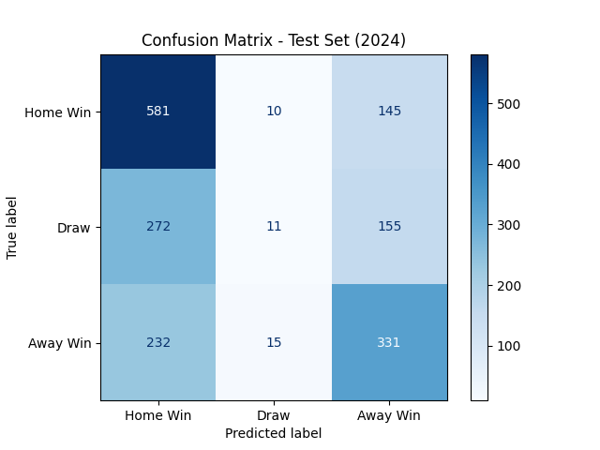
Figure 1: Confusion matrix for the 2024 test season showing predicted versus actual match outcomes (Home Win, Draw, Away Win).
The confusion matrix highlights the model’s classification performance across the three outcome classes. Home wins are predicted with relatively high accuracy, as indicated by the strong diagonal values. In contrast, draw outcomes are significantly underrepresented and frequently misclassified as either home or away wins. Away wins are predicted with moderate accuracy but are occasionally confused with home wins.
These results reflect the inherent difficulty of predicting draws in football, as well as the class imbalance present in the dataset.

Appendix B — Feature Importance Analysis
Figure 2 presents the top 10 most important features used by the XGBoost model for predicting match outcomes.
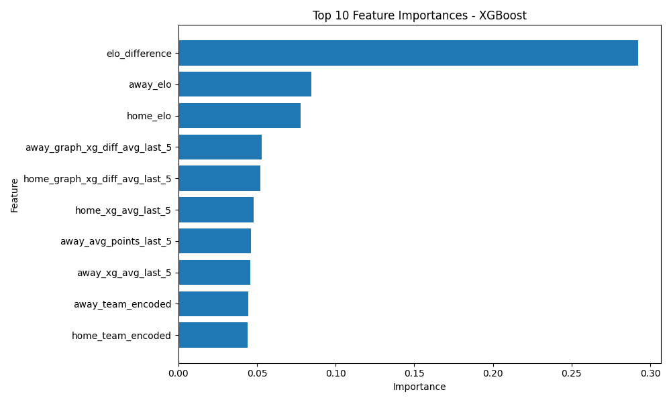
Figure 2: Top 10 feature importances for the XGBoost model, showing the relative contribution of each feature to prediction decisions
The feature importance analysis reveals that the most influential variable is the Elo difference between teams, which dominates all other features. This indicates that relative team strength is the primary factor driving match outcome predictions.
Additional important features include individual team Elo ratings (home and away), as well as rolling performance metrics such as expected goals (xG) averages and xG-based performance differentials over the last five matches. These features capture both long-term team strength and short-term form.
Notably, encoded team identity features exhibit lower importance, suggesting that the model relies more on statistical performance indicators rather than memorizing specific teams.

Appendix D — Sample Model Predictions
Table 1 presents a sample of predicted probabilities generated by the XGBoost model for matches in the test dataset. For each match, the model outputs the probability of a home win, draw, and away win.
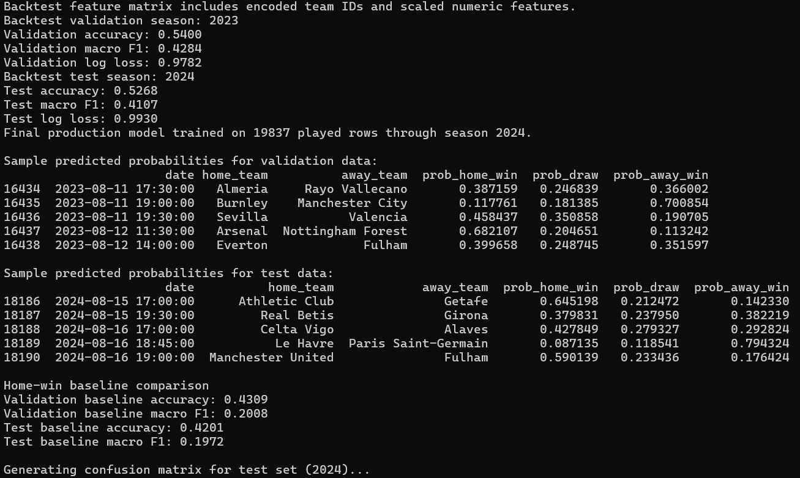
Figure 3: Model evaluation output including validation and test metrics, baseline comparison, and sample predicted probabilities for selected matches.
Date | Home Team | Away Team | P(Home Win) | P(Draw) | P(Away Win)
2024-08-15 | Athletic Club | Getafe | 0.645198 | 0.212472 | 0.142330
2024-08-15 | Real Betis | Girona | 0.379831 | 0.237950 | 0.382219
2024-08-16 | Celta Vigo | Girona | 0.427849 | 0.279327 | 0.292824
2024-08-16 | Le Havre | Paris Saint-Germain | 0.087135 | 0.118541 | 0.794324
2024-08-16 | Manchester United | Fulham | 0.590139 | 0.233436 | 0.176424
Table 1: Sample predicted probabilities for match outcomes.
These results illustrate that the model produces probabilistic predictions rather than deterministic outcomes, capturing uncertainty in match results. The variation in predicted probabilities across matches reflects differences in team strength and recent performance.

Appendix E — Contribution of Group Members
Table 2 outlines the contribution of each group member to the different components of the project. The project was developed collaboratively, with all members contributing across multiple stages including data processing, model development, evaluation, and report writing.
Student Name | StudentId | Contribution
Arya Kumar Ramsurn | 2315032 | Data preprocessing, feature engineering, model implementation, evaluation (baseline comparison, confusion matrix, feature importance), report writing
Tirthesh Parbutee | 2310967 | Data collection from Understat, preprocessing, feature engineering, model training, evaluation, report writing
Shreeyash Sewnundun | 2310930 | Feature engineering, model implementation, Monte Carlo simulation, results analysis, evaluation, report writing
Table 2: Distribution of work among group members.

